**Name: Eshan Singh**

**BEAD21228**

**BE - B**

**Assignment No 03**

**Problem Statement:** Protein Structure Prediction. Predict the 3D structure of a given protein sequence using homology modeling or threading techniques.

**Output:**

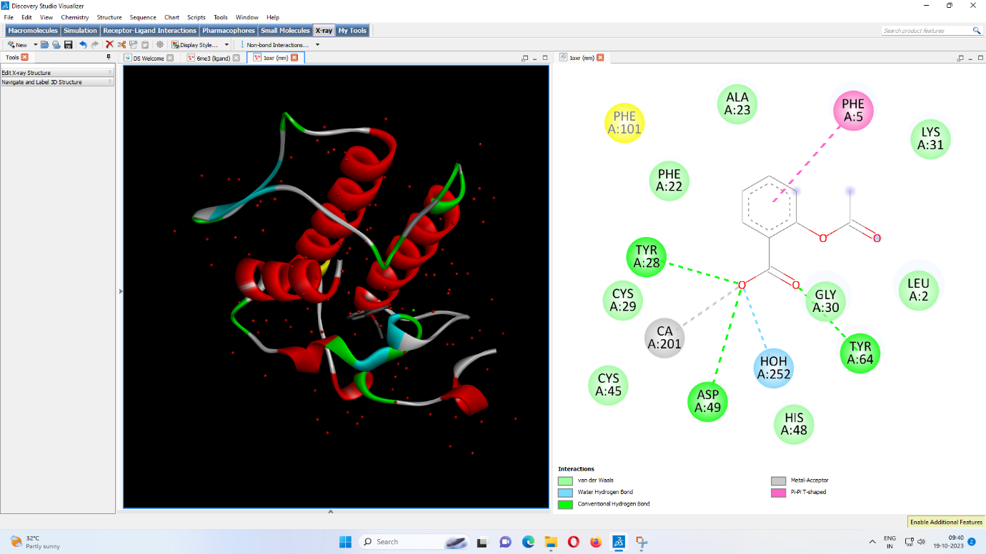

**Interactions:**

Van Der Waals

Water Hydrogen bond

Conventional Hydrogen bond

Metal-Acceptor

Pi-Pi T-shaped

**Eshan Singh**

**BEAD21228**

**BE - B**

**Assignment No 04**

**Problem Statement:** Molecular Docking and Virtual Screening. Perform molecular docking simulations to predict the binding affinity between a protein target and a small molecule ligand. Additionally, conduct virtual screening to identify potential drug candidates.

**Output:**

